Jack Berberian

CIS 245

Getting Your Systems Set Up Pt 1 – CentOS Stream 9 Redo

2/5/2022

How to Install CentOS Stream 9 on a VirtualBox Virtual Machine

If You Don’t Have your System Set Up

1. Go to <https://www.virtualbox.org/wiki/Downloads> and then download the version for your system, (Windows, Mac, Linux).
2. Install it once it’s ready.
3. Go to <https://www.centos.org/download/>, click on CentOS Stream and make sure 9 is selected and then select the version of the OS for your system under Architectures. (Most common is x86_64 for 64Bit Windows 10)
4. Download the file somewhere accessible and then get it ready for VirtualBox.

If You Do Have Your System Ready

1. Launch VirtualBox and create a new virtual machine (VM).

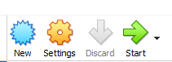

1. Make a name for the virtual machine and then add about 3000MB of memory, and then make sure Create a virtual hard disk now is selected.

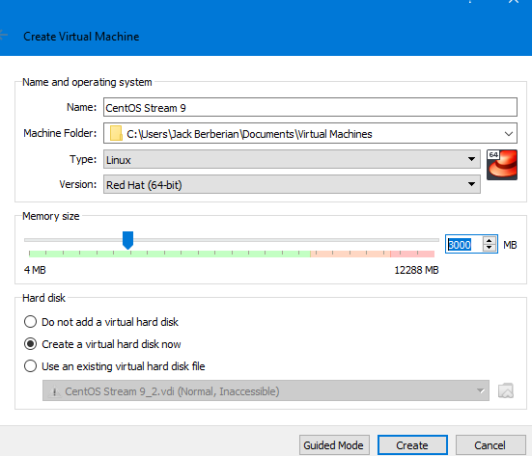

1. On the next page, make sure the virtual hard disk file size slide is 20GB and then press next.

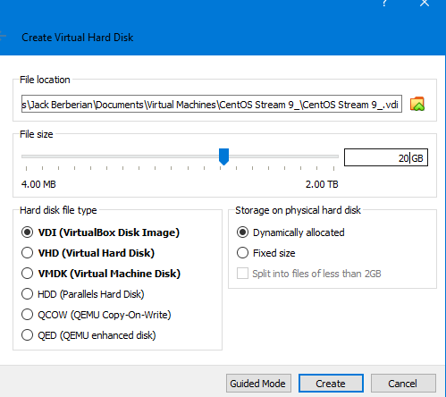

1. Go to Settings, General, Advanced, and then make sure Shared Clipboard and Drag and Drop is set to Bidirectional.

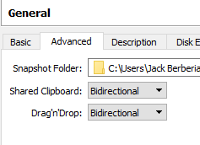

1. Go to Settings, System, and then Motherboard and uncheck Floppy.

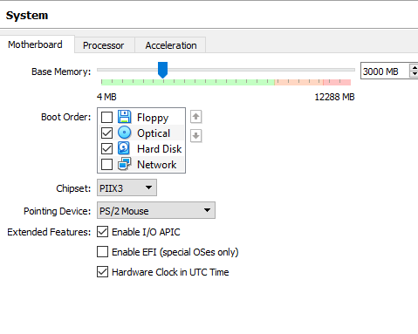

1. Go to Settings, Display and then make sure Video Memory is set to 64MB or approximately half of your allotted amount for your computer.

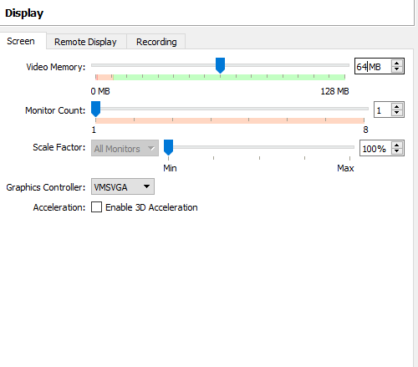

1. Go to Settings, Storage and then under Controller: Ide, press the empty drive, and then click the CD next to the optical drive dropdown box and select choose a virtual disk file and then navigate to the file that was downloaded before.

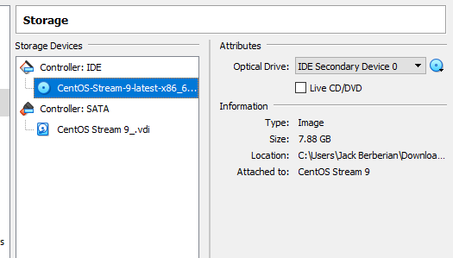

1. Lastly, go to Network, and under Bridged Adapter, make sure Attached To: says Bridged.

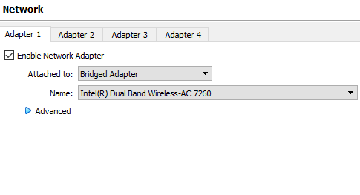

1. Once settings are changed, press Start and wait for the virtual machine to boot.
2. Once the virtual machine boots up, you can either select Install CentOS Stream 9 or wait for it to automatic boot.

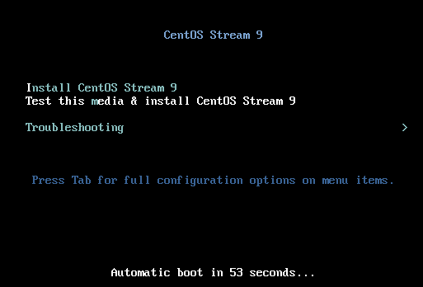

1. When the virtual machine is up, select your language and then press continue.

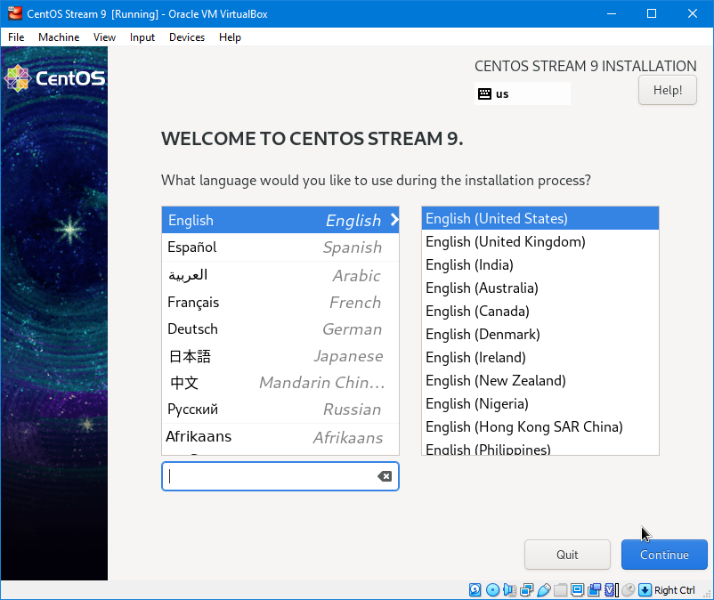

1. In the installation summary menu, go to Installation Destination and make sure the ATA VBOX HARDDISK is selected and then press Done to go back.

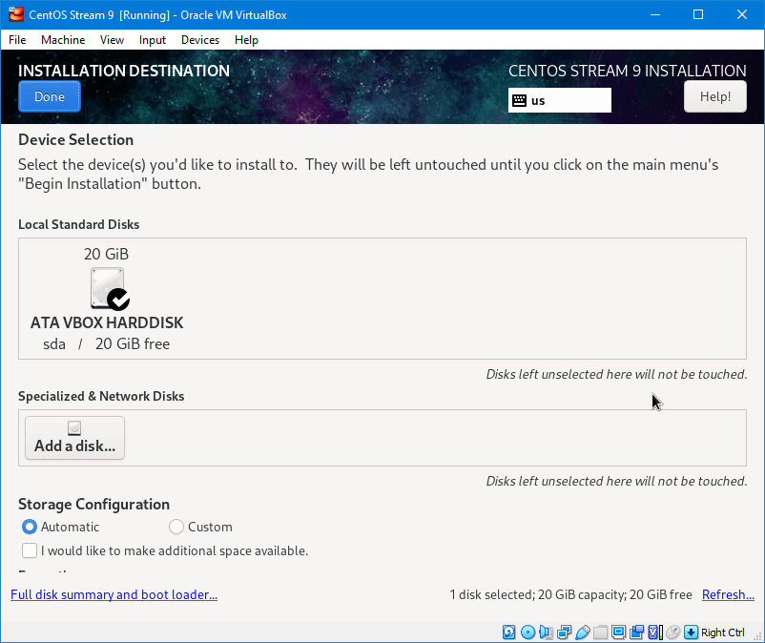

1. In the software selection menu, under the additional software for selected environment, select File and Storage Server, Network File System Client, Windows File Server, System Tools and then press done to back to the main menu. Under base environment, select Server.

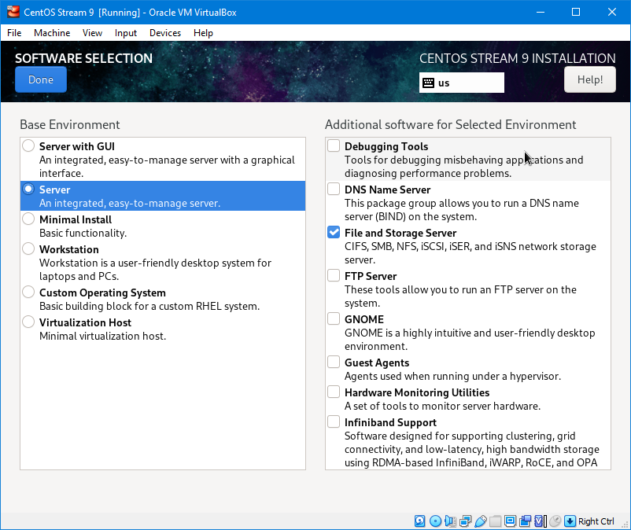

1. Under Network & Host Name, if the Network Adapter was set to Bridged in the earlier step, you should be fine and then you can enter anything for a Host Name or what the system will be called.

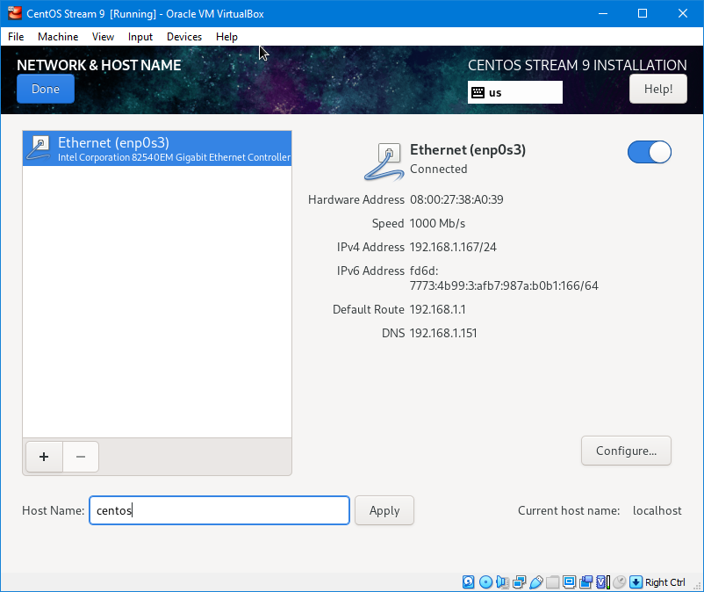

1. Under root password, enter a password for root and select allow root ssh login with password.

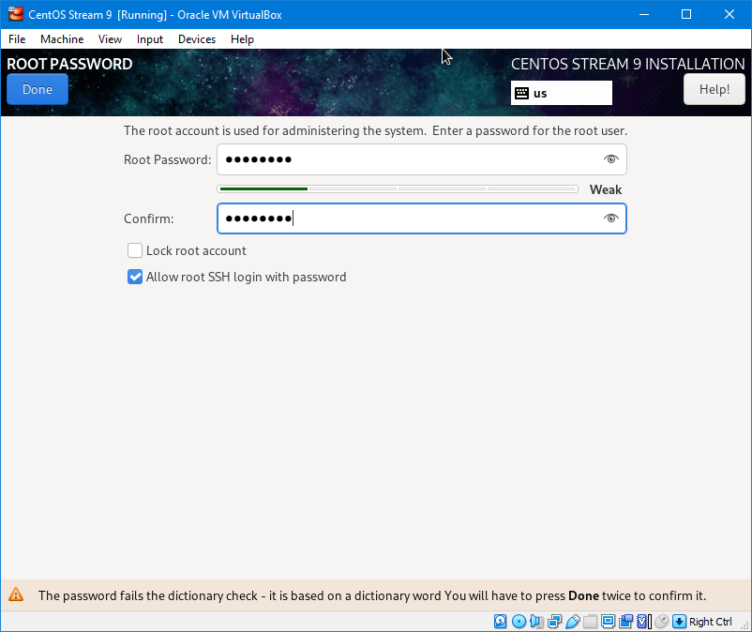

1. After finishing with the root password, go back to the main menu and press Begin Installation.

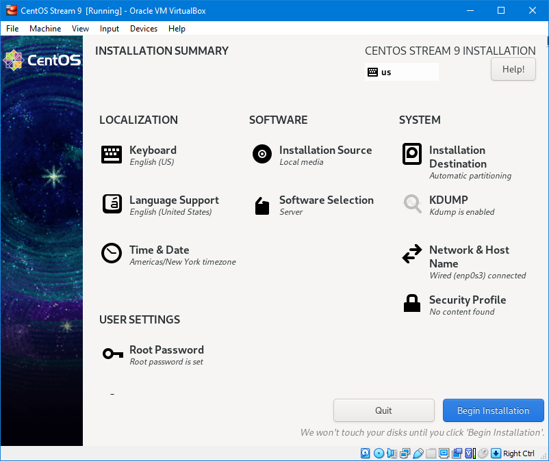

1. Once the installation is finished, press reboot system.

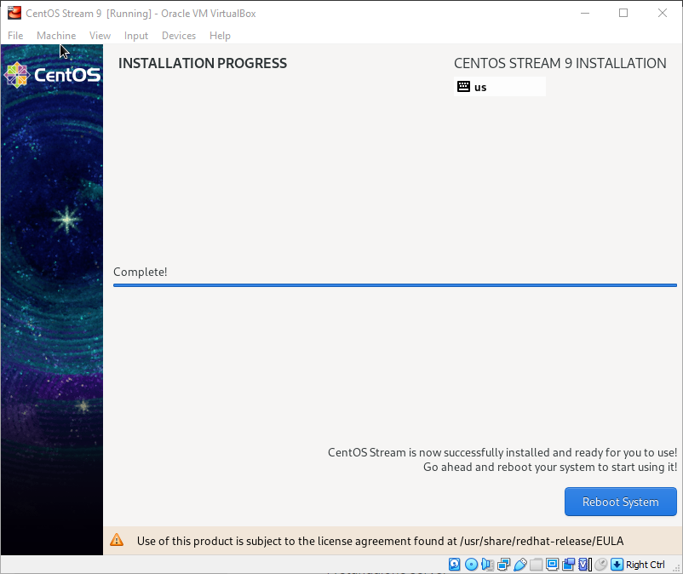

1. Once the system reboots, enter root for the username and the password that was made earlier.

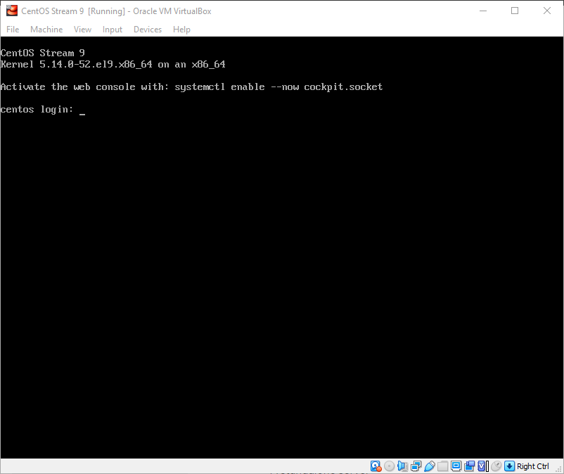

1. Success! You’ve installed CentOS.

How to Share Files

One way to share files is with a program called WinSCP.

1. Go to <https://winscp.net/eng/index.php> to download and install the program.
2. Launch the program and enter the hostname (systemname) from earlier, root username from earlier and the password from before and then press Login.

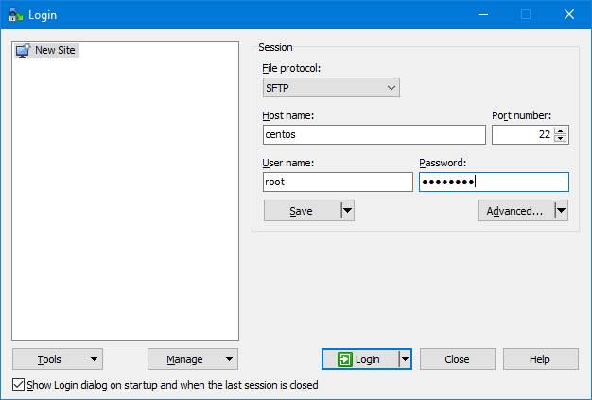

1. Once logged in successfully, you can transfer files.

